OUTPUTS

**1.Spring-rest-handson1**

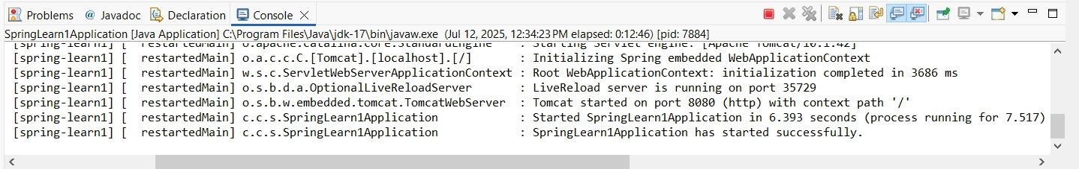

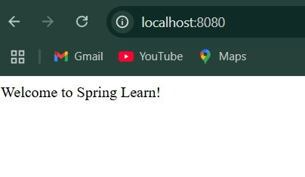

**2.Spring-rest-handson2**

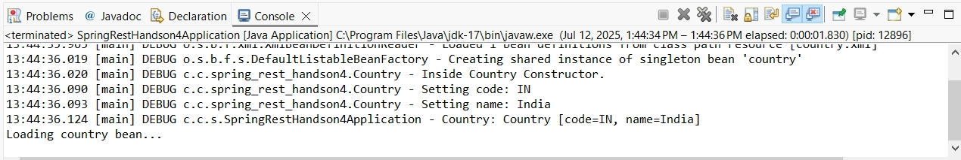

**3.Hello-World-RESTful-Web-Service**

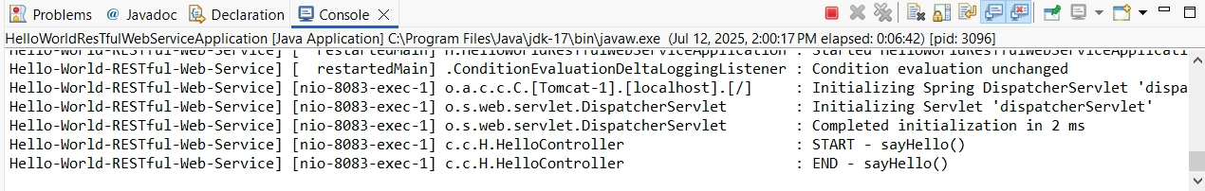

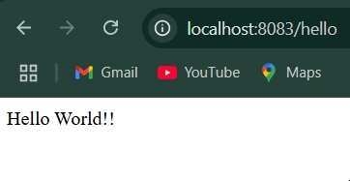

**4.REST-Country-Web-Service**

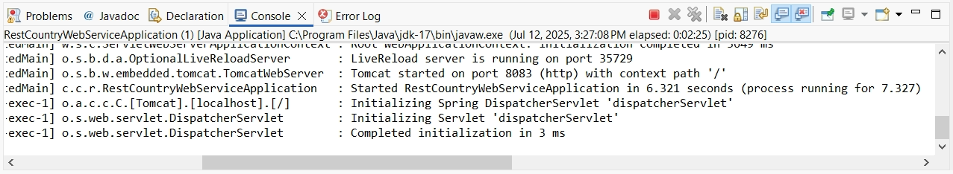

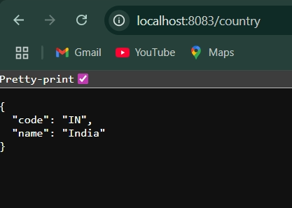

**5.REST - Get country based on country code**

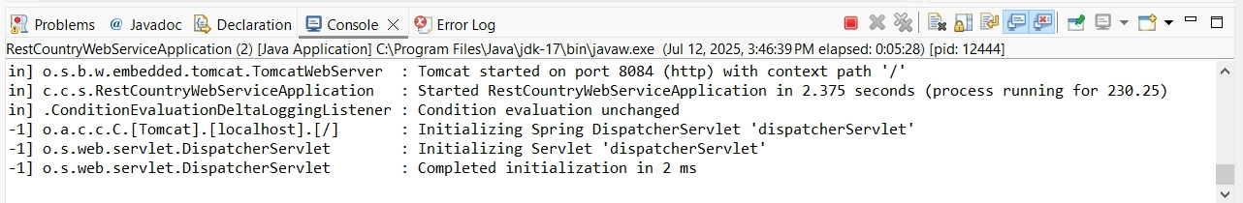

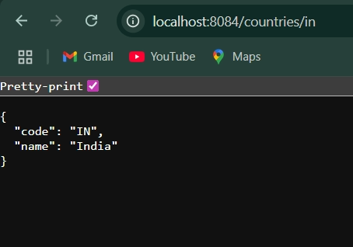

**6.Create authentication service that returns JWT**

